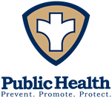
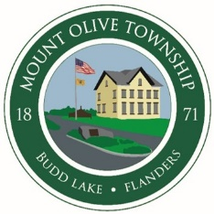
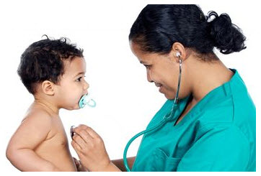
Free Child Health Clinic
The Township of Mount Olive is sponsoring a Free Child Health Exam & Vaccines for resident children of Mount Olive, Netcong and Mount Arlington who do not have health insurance or have NJ Family Care A.
A licensed Pediatrician will perform physical examinations and update vaccinations.
Ensure your child’s health and well-being by participating in this free event. It is a chance to make sure your child is up-to-date on their required vaccinations before the next school year.
When: Tuesday, September 25, 2018 from
1:00 pm- 3:30 pm
Where: Mount Olive Township Health Department, 204 Flanders-Drakestown Road, Budd Lake 07828

